
DELHI PUBLIC SCHOOL, BANARPAL
School no- 15349, Affiliation No-1530200
CLASS 10TH BOARD EXAM RESULT-2026
GENERAL BATCH
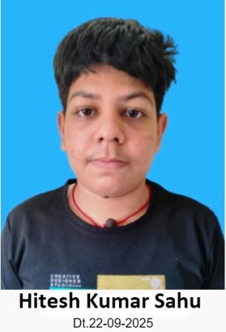
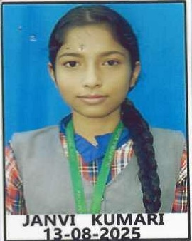
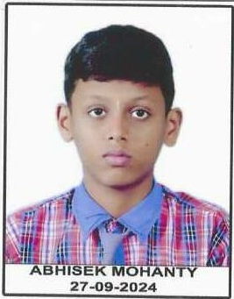
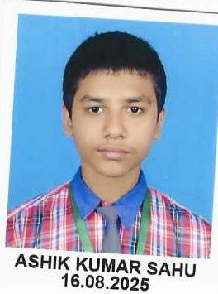

ASHIK KUMAR SAHU ABHISEK MOHANTY JANVI KUMARI
93% 80.2% 87%

HITESH KUMAR SAHU
83.2%

DELHI PUBLIC SCHOOL, BANARPAL
School no- 15349, Affiliation No-1530200
CLASS 10TH BOARD EXAM RESULT-2026
ANWESHA BATCH

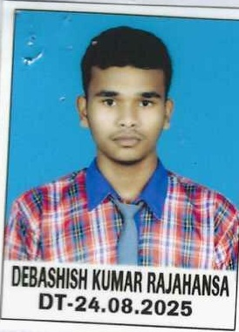
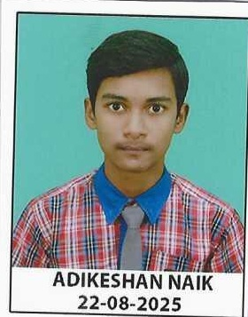
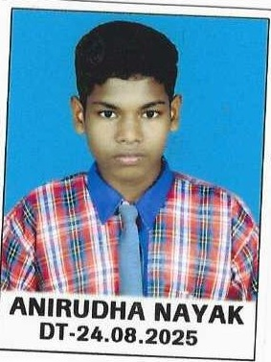
ADIKESAN NAIK ANIRUDHA NAYAK DEBASISH KUMAR RAJHANSA
84.2% 78% 77%

DELHI PUBLIC SCHOOL, BANARPAL
School no- 15349, Affiliation No-1530200
CLASS 10TH BOARD EXAM RESULT-2025

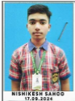
SUSHRUTAM MISHRA NISHIKESH SAHOO PRAKRUTI PRIYADARSINI SAHU
89.20% 86.80% 84.80%

